Appendix 2 – Example Assessment Case

The assessment cases should be constructed to give the students an opportunity to demonstrate that they have reached each of the learning objectives. In order to reflect the complex nature of the topics as well as variance in student backgrounds it is suggested that the main assessment cases are an ongoing process during the entire span of the course. The case report should be treated like a portfolio where additions are made continuously.

As initial “warm-up” in lesson 1 a case on bunker fuel may be used such as:

With a significant amount of self-study time, the course participants are expected to refresh their mathematics and statistics knowledge as preparatory requirement of the course.

The example provided here can serve as group discussion on such basic statistical application in the maritime framework.

Officers should be able to theoretically handle the following:

See the graphs in the publication from Schinas/Stefanakos (2013). The graphs show the price of bunkers in various ports.

For example, use figure 7. In this graph you see a distribution of prices that resembles to a normal or a log-normal distribution.

However, no safe results can be extracted as the Empirical Cumulative Distribution Function (ECDF) is not 'full' as in theory see here https://en.wikipedia.org/wiki/Cumulative_distribution_function
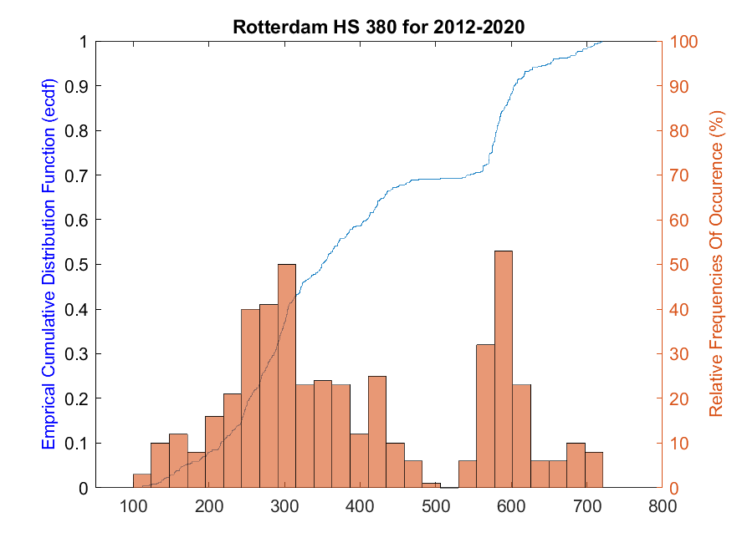

The results of Fig 3 or even of the attached graph (updated graph with data till 2020) cannot be 'interpreted' or handled without specialized knowledge of statistics; even students of mathematics are not supposed to know 'how to handle' a bimodal distribution, although it is common in science and has many applications.

For example, in the attached graph the mean is close to 450 USD, yet this is a 'weak' region (frequency of occurrence is low), so the mean should be calculated in a different way (different methodological handling).

In this regard the thresholds between the regions of knowledge gained from school, knowledge gained and applied in an MTC, and the knowledge available for use onboard should be clearly defined and a minimum level of skills and competences mastered should be the core objective of a new regulation or MTC curriculum.

The backbone of the assessment case should be a raw dataset upon which the various theories and methods can be used. Additional information and background story should be made to put the dataset into context and allow the students to reflect upon specific circumstances as well as the more general data processing.

The case should provide the opportunity to work on each of the five main learning streams after completing the lectures connected to them. In addition, it should also require students to revisit earlier parts of their case portfolio to correct or optimize these when new synergies and revelations in the later lectures are discovered.

A key element of the module will be analysis and understanding of the THETIS data provided by EMSA (https://mrv.emsa.europa.eu/#public/emission-report). Case for single vessels, groups of vessels and a vision of the entire segment should partially be taken from these data.

